Studio Rules & My Deck Check
I can check my own pages against the studio rules and fix what fails. | ○ ○ ○
Name: ______________________________ Class: ________ Date: ____________
Part 1 — The Studio Rules card (Activity 2.2)
✂ PIXEL & PINE — STUDIO RULES
Copy the eight rules from the wall. Keep this card in your book.
1
2
3
4
5
6
7
8

Part 2 — Repair Dato’s deck in Canva (Activity 2.3)
Open Dato’s deck from the link. Canva gives you your own copy. Tick each step when it is done.
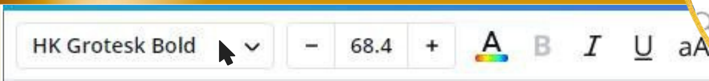
Click a text box once — this toolbar appears at the top.
☐ | 1 | Size: click the text, then use – and +.  Titles 32 pt or more. Nothing under 18 pt.
☐ | 2 | Colour: click the A with the rainbow line.  Dark text on a light background, or light on dark.
☐ | 3 | Font: choose ONE font family for all four pages.
☐ | 4 | Line up: drag slowly until the pink guides appear, then let go.  Or: click it → Position → Align to page.
☐ | 5 | Copy style: right-click the good text → Copy style → click the text to fix.  Windows keys: Ctrl + Alt + C, then Ctrl + Alt + V.
☐ | 6 | Double-click to change words.  ⚠ Never delete the text box and draw a new one — you lose the design.

Part 3 — Check YOUR deck (Activity 2.4)
Open your own deck. Only one page? Duplicate it until you have six, then give each page a heading. For every page, write ✓ if it passes the rule, or ✗ if it fails. Fix every ✗.
Rule | P1 | P2 | P3 | P4 | P5 | P6
1 About six words a line
2 Readable from the back (18 pt +)
3 Dark text on a light background
4 One font family on every page
5 Things lined up
6 Biggest = most important

The two-metre test
Stand up. Step back two metres. Can your partner read every word on your screen?
Partner’s name: ______________________ Passed? YES / NOT YET

The rule my deck failed most:

The fix I made:
Challenge
★★ | On your page 1, what does your eye land on first? Is that the most important thing?  _______________________________________________________________________________

★★★ | Choose the page you are proudest of. Name two rules it follows and explain how each one helps a Grade 3 visitor at the museum.  _______________________________________________________________________________  _______________________________________________________________________________

Before you log off
Check your design name is still correct. There is no Save button — Canva saves by itself. Log out.

